**Summary**

Congratulations! You're ready to deploy your model.

Once you have trained your model, have evaluated its effectiveness, and are satisfied with the results, you're ready to generate predictions on real-world problems using unseen data in the field. In machine learning, this process is often called **inference**.

**Iterative Process**

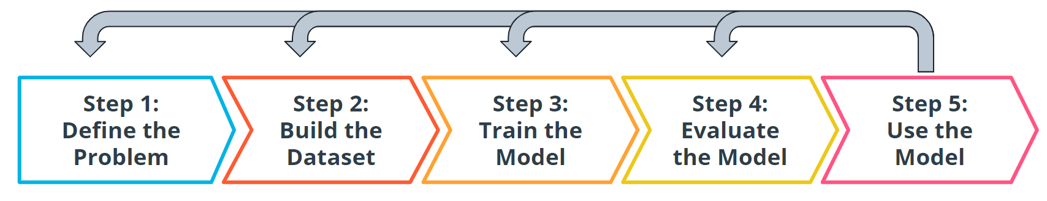

Iteration of the entire machine learning process

Even after you deploy your model, you're always monitoring to make sure your model is producing the kinds of results that you expect. Tthere may be times where you reinvestigate the data, modify some of the parameters in your model training algorithm, or even change the model type used for training.

;